Nama : Rani Meliyana Putri

NIM : 11191062

TUGAS 3 – PEMROGRAMAN FUNGSIONAL B

1. Singleton

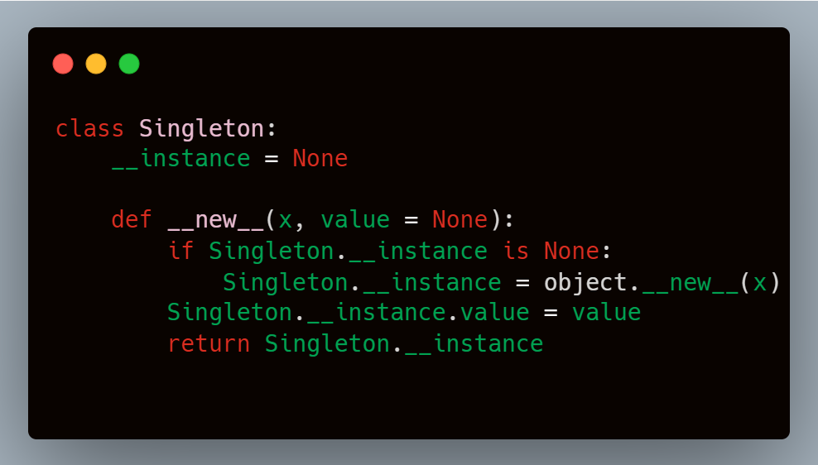

1. Abstract Factory

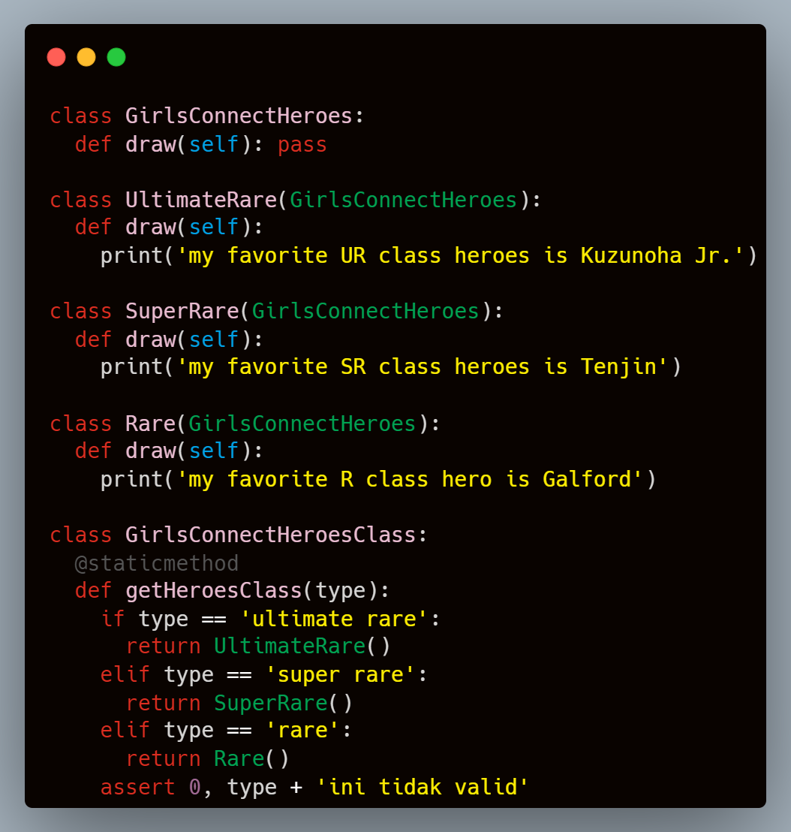

1. Prototype

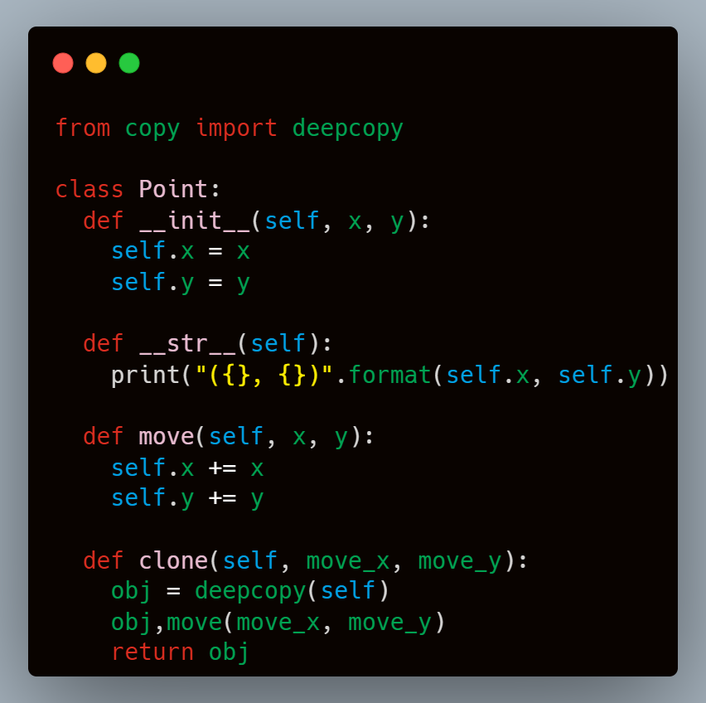

1. Builder

